R Plots using ggplot2, plotly & googleVis

R has excellent visualization packages like ggplot2, lattice, plotly etc. used the primary Indian industrial data; "Annual Survey of Industries" to summarize different aspects of Indian industries using ggplot2 visualization.

First let’s plot no. of workers per firm in different states. A bar plot would have sufficed for comparison but the jitter plot shows the concentration of firms according to their workforce. If you consider 'no. of workers' as a proxy for larger firms; you can see the concentration of larger and smaller firms of a state vis-a-vis with other states.

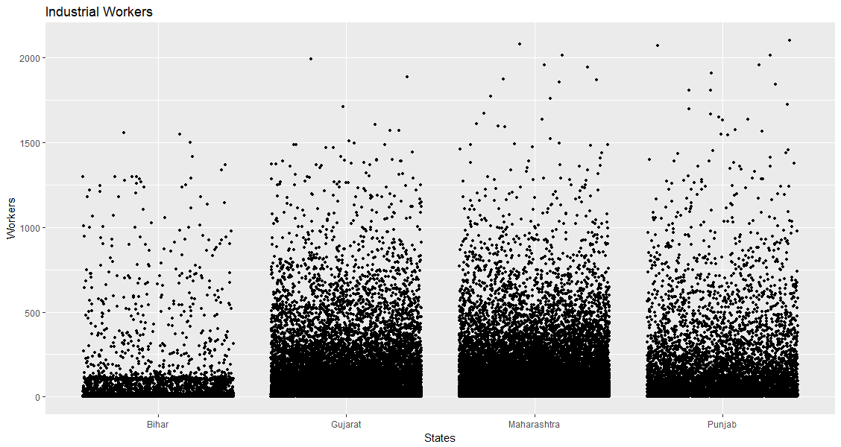

Now let's see the relationship between number of workers and gross value added of firms in a scatterplot with regression lines.

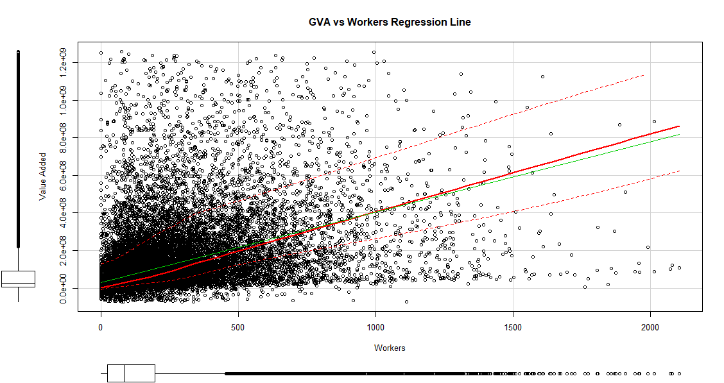
You can see a much steadier relationship between value added and workforce especially in the first half of the plot.

Now let’s visualize some interesting plots in a IMDB 5000 movies dataset. First one is a scatter of gross earnings of movies plotted against their budget and movies are categorized as good, average and bad by their IMDB viewer ratings.

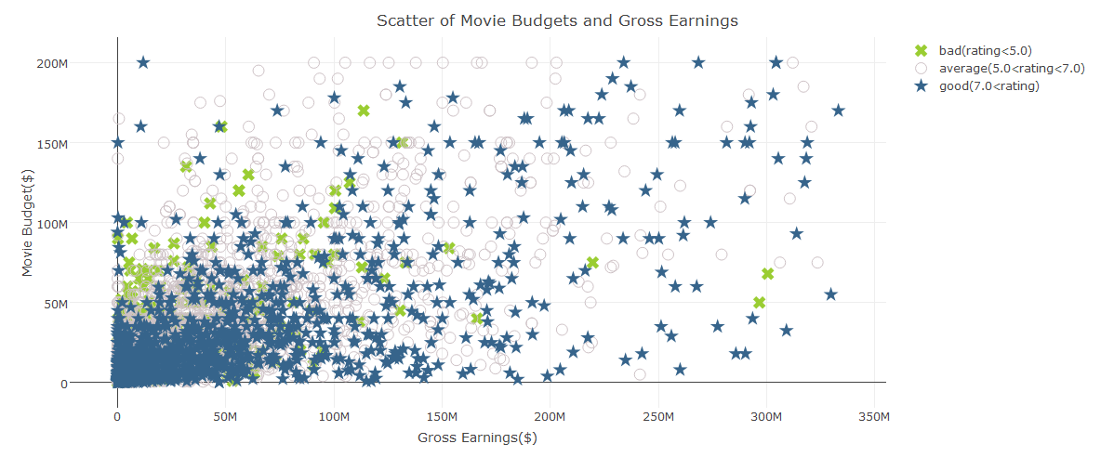
Let’s investigate the relationship further. We can see, higher the IMDB ratings; the relation between gross returns and budget is more linear.
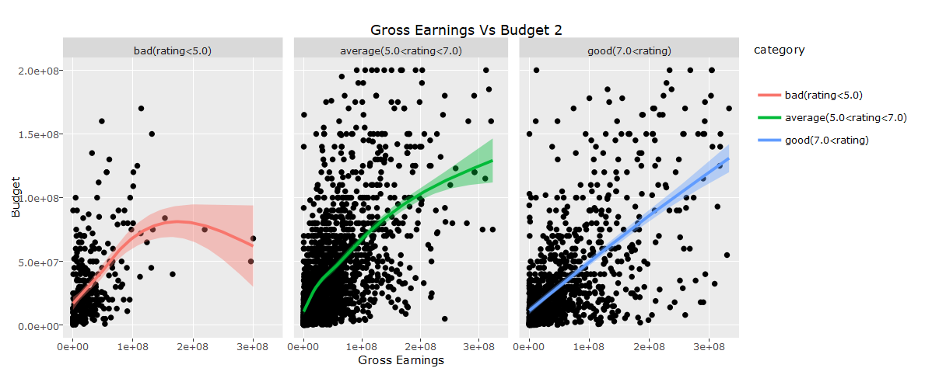

A google map intensity plot using global terrorism index dataset; showing state wise terrorist incidents in India.

